Declaration of Performance
(WJ Fire Retardant Ltd DoP Eucalyptus Plywood BF 2)
- Product Type: Eucalyptus plywood with face veneer treated with fire retardant Burnblock. EN14915:2013 + A1:2017

- Intended Use: Fire treated eucalyptus plywood with beech face veneer for panelling and cladding applications in construction. Suitable for use with horizontal and vertical joints, and with ventilated or non-ventilated air gaps or no air gap between the product and substrate. End use substrate to be Euroclass A1 or A2 - s1, d0.

- Manufacturer: <<WJ Fire Retardant Ltd, 1A Main Street, Kirkburn, Driffield, East Yorkshire, YO25 9DU. E-mail: info@firewright.co.uk>>.

- System of Assessment and verification of constancy of performance: AVCP-system 1

- Construction product covered by a harmonized standard: Finotrol Oy, Notified certification body no: 2412 has performed initial inspection of the manufacturing plant and production control and performs continuous surveillance, assessment and evaluation of factory production control under system 1 and issued the certificate of conformity of factory production control: 2412-CPR-1019-01.

- Declared Performance:

Essential charecteristics | Performance | Harmonised technical specification
Wood species | Eucalyptus Plywood with Beech Face (Eucalyptus globulus) | EN 14915:2013 + A1:2017
Density, thickness | 744 kg/m³ (undried), 5.5 mm | EN 14915:2013 + A1:2017
Reaction to fire | B-s1,d0 ≤ 5,5mm  B-s2,d0 > 6mm | EN 14915:2013 + A1:2017
Release of dangerous substances | NDP | EN 14915:2013 + A1:2017
Treated to fire classification  Natural Durability class  Uptake  Name of treatment chemical | EN 13501-1:2007+A1:2009  1  40 kg/m3  Burnblock | EN 14915:2013 + A1:2017
Signed for and behalf of the manufacturer by: 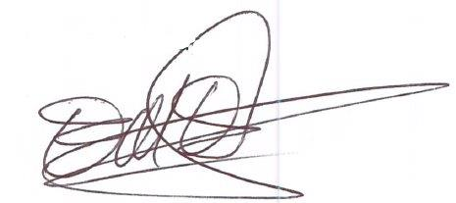
Name and function: Mark Eggleston, Managing Director

Place and date of issue: WJ Fire Retardant, Kirkburn 24/1/2024

