Declaration of Performance
(WJ Fire Retardant Ltd DoP Accoya) Option 2
- Product Type: Accoya modified Pinus radiata solid wood panel. End use as a cladding or as a support for cladding elements.

- Intended Use: Fire treated solid wood panelling and cladding for applications in construction. Horizontal and vertical joints. Ventilated or on-ventilated air gap between product and substrate or no air gap. End use Substrate of Euroclass A1 or A2 – s1, d0 ≥ 12 mm, density ≥ 525 kg/m3

- Manufacturer: WJ Fire Retardant Ltd, 1A Main Street, Kirkburn, Driffield, East Yorkshire, YO25 9DU. E-mail: info@firewright.co.uk.

- System of Assessment and verification of constancy of performance: AVCP-system 1.

- Construction product covered by a harmonized standard: Finotrol Oy, Notified certification body no: 2412 has performed initial inspection of the manufacturing plant and production control and performs continuous surveillance, assessment and evaluation of factory production control under system 1 and issued the certificate of conformity of factory production control: 2412-CPR-1019-01.

- Declared Performance:

Essential charecteristics | Performance | Harmonised technical specification
Wood species | Accoya (Pinus Radiata) | EN 14915:2013 + A1:2017
Density, thickness | 568 kg/m³, ≥ 19 mm | EN 14915:2013 + A1:2017
Reaction to fire | B-s1,d0 < 19mm  B-s2,d0 ≥ 19 mm | EN 14915:2013 + A1:2017
Release of dangerous substances | NDP | EN 14915:2013 + A1:2017
Treated to fire classification  Natural Durability class  Uptake  Name of treatment chemical | EN 13501-1:2007+A1:2009  1  76.2 kg/m³  Burnblock | EN 14915:2013 + A1:2017
Signed for and behalf of the manufacturer by: 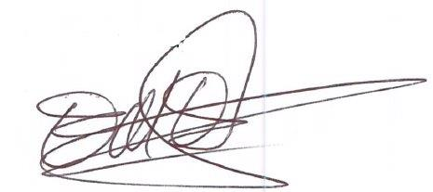
Name and function: Mark Eggleston, Managing Director

Place and date of issue: WJ Fire Retardant, Kirkburn
24/1/2024

